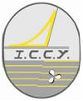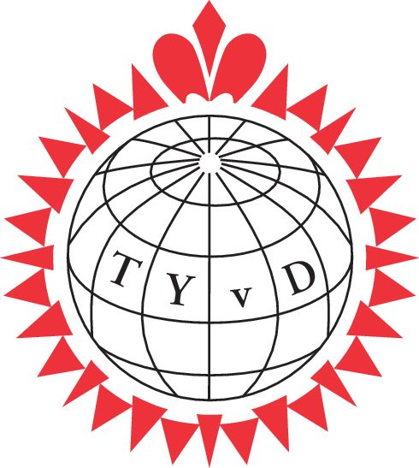

TYvD and ICCY Autumn Meeting 2019 in Hamburg
Program and Registration

Thursday, November 7th 2019 – Arrival Day

14.00 onwards, Rooms available at Hotel Behrmann,
Elbchaussee 528, 22587 Hamburg Blankenese
Tel. 040 86 69 72 0
Fax 040 86 69 72 49

19.00 Dinner at Hotel Behrmann (incl.), Drinks at own cost

Friday, November 8th 2019

Visit of Airbus airplane factory www.airbus.com

09.30 Public Bus to Teufelsbrück, Ferry to Finkenwerder, bus or walking to the factory location. Visit of Airbus factory ( 2,5 h )
10.50 Arriving at Airbus and check in ( you need your ID card )
11.10 Start of factory tour
13.40 Finish of factory tour and way back to Ferry station
14.00 Ferry to Teufelsbrück and lunch at „Dübelsbrücker Kajüt“ (at Ferry station)
( lunch included, drinks at own cost)
Free time in the afternoon and arrival of people who wish to join from Friday only
19.00 Dinner at Restaurant „Witthues Hirschpark“
(dinner included, drinks at own cost, dress code casual)

Saturday, November 9th 2019

09.00 Small guided city tour by bus on the way to the Emigration Museum „Ballinstadt“ www.Ballinstadt.de
11.00 Visit of Ballinstadt Museum
13.00 Lunch at the museum in the Restaurant „Nordamerika“
(lunch included, drinks at own cost)
Afterwards bus drive to the concert hall “Elbphilharmonie” and walking tour at
the visitor platform “Plaza”
Free afternoon or back to Blankenese by water bus, returning to the hotel or optional mulled wine / hot chocolate at Süllberg / Blankenese
19.00 Welcome Drink, Gala Dinner and music at Restaurant „Sagebiels Fährhaus“
(welcome drink, dinner included, drinks at own cost, dress code formal with tie)

Sunday, November 10th 2019

ICCY Council Meeting ( time tbd ) and departure

Please make your own hotel reservation under „ICCY“ im Hotel Behrmann, Elbchaussee 528, 22587 Hamburg

Tel. +49 40 86 69 72 0
Fax +49 40 86 69 72 49

Room rate for double room 100,-- € per night incl. breakfast, free car park and Wlan
Resvation by mail under
reservierung@hotel-behrmann.de, Codename ICCY

The above-mentioned conditions are reserved until Sept. 7th 2019

As usual, none TYvD or ICCY members are very welcome to join as guests!

