

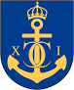

**The 37th International Council of Cruising Yachts**

**Preliminary PROGRAM July 16-20, 2018**

**Monday 16th July (day of arrival)**

12:00 – 16:00 Arrival at Karlskrona and registration.  
17:00 – 18:00 Welcome drink and flag ceremony.   
 Greetings from the Municipality of Karlskrona.

- Karlskrona – a World Heritage City. The guide Michael Helgesson will take you on a virtual tour, explaining in his own way Karlskronas history and how our countries (visiting nations) are connected.  
19:00 – 23:00 Welcome buffé at Sjörök. A glass of wine or beer included.  
  
**Tuesday 17th July**   
09:00 “A day at Sea”.

Guided boat tour and visit to Kungsholm Fortress, with coffe break.  
12:00 – 13:00 Lunch at the Drottningsskär Citadel. Non alcoholic drinks included.   
13:00 – 16:00 Visiting Drottningsskär Citadel with a guided tour.  
16:30 Return back to our boats.

18:00 – 19:00 Reception and Welcome to Karlskrona, by the Governor of Blekinge. Dress code, Smart causal.  
 walking distance from the harbor  
  
**Wednesday 18th July**   
09:00 – 11:30 Bus tour to the Old Naval Shipyard (military area) with a guided tour.  
12:00 – 13:00 Lunch buffé at Naval Museum.

13:00 – 15:00 Visiting Naval Museum by your own.

18:00 Coach to taking us to Karlskrona Sailing Socity, “KSS” and barbecue dinner. B.Y.O. wine or beer.

23:00 Return back to our boats.

**Thursday 19th July**

09:00 – 12:00 Guided tour in old city of Karlskrona.  
14:00 – 15:30 Council meeting.  
19:00 – 23:00 Gala dinner at the Naval Museum, incl. drinks in the Hall of Figureheads  
  
**Friday 20th July**

09:00 – 11:00 Brunch

11:30 – 12:00 Flag ceremony  
Farewell back home or stay another day…………

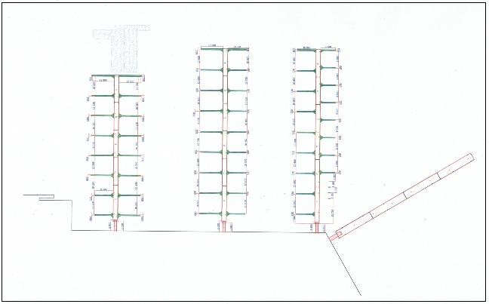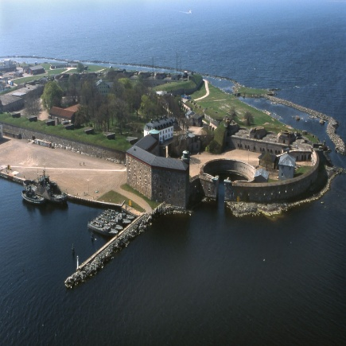

|  |  |
| --- | --- |
|  |  |
|

KARLSKRONA GUEST HARBOR KUNGSHOLMS FORTRESS

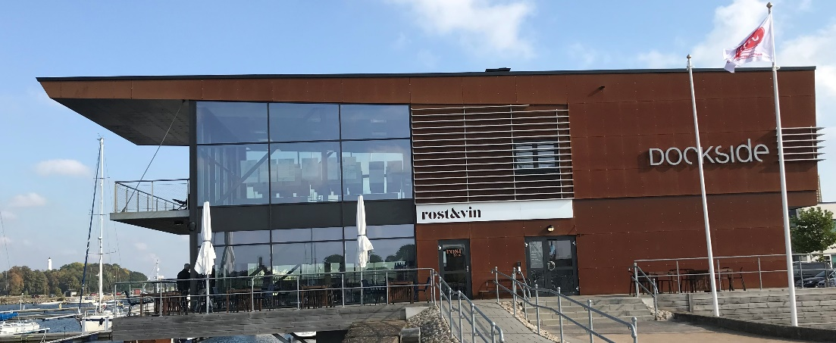

ROST & VIN

For those who would like to stay in hotel, we can advise the Hotel Karlskrona, close to the marina  
*Please observe that the program may change without any further information. Please keep yourself updated*