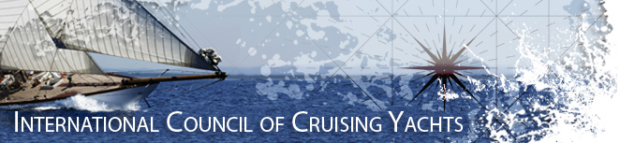

**ICCY REGISTRATION FORM e**uro version 17.05.2017 **Ipswich, 3rd to 6th November 2017**

Please return page 1 and part of 2 of this completed form to: [reg@iccy.org](mailto:reg@iccy.org) who in turn will copy it to the UK.

My crew and I wish to participate in the Autumn ICCY Council Meeting at Ipswich 2017.

**Owner / Skipper**

Surname: .............................................................. Given Name: ..........................................

Postal Address: .............................................................. Sailing/Yacht Club: ..........................................

.............................................................. ............ ....................................................................

Post Code: .............................................................. Nationality: ..........................................

City: .............................................................. Telephone Number: ...........................................

Country: .............................................................. Mobile: ...........................................

e-mail: ...............................................................

Any dietary restrictions? ………………………………………………

**Crew**

|  |  |  |  |  |
| --- | --- | --- | --- | --- |
| N⁰ | First Name | Surname | Passport Number | Fee |
| 1 |  |  |  |  |
| 2 |  |  |  |  |
| 3 |  |  |  |  |
| 4 |  |  |  |  |

Tour Guides

I would prefer an English speaking guide ………. or German speaking guide ………..

ETA

Stansted Airport or London Liverpool Street Station SA…………………LST…………

Expected time Ipswich and Hotel …………………………………….

Flight options. It seems that for Finnish and Swedish ICCY members decently priced flights are available only to London Heathrow. This means Heathrow Express to London Paddington, underground Liverpool Street and change to Greater Anglia to Ipswich. For German, Dutch and French members there are plenty of options to Stansted. Ryanair flies from Tallinn to Stansted. Maybe an option for the Finns as well.

Ring +44 771 157 6843 to let us know you have arrived at the Hotel. See you at the bar, Fox’s Marina for a sociable welcome.

Coach travel for the weekend by Beeston’s Coaches, Hadleigh & Saturday evening JR Travel, Copdock.

ICCY Banner 001.tif

Payment

Together with the registration I agree a down payment of 50% of the total cost in Euros to the ICCY.

**International Council of Cruising Yachts IBAN FI5715553000113002 BIC: NDEAFIHH**

Please forward pages 1 and 2 to [reg@iccy.org](mailto:reg@iccy.org) so that your registration is recorded.

ICCY will convert to euros and remit to the UK Organiser.

I also undertake to pay the balance upon arrival (or before day of arrival to above bank account)

As owner / participant I am aware that I have full responsibility of my crew and myself, and shall not hold the Event Organiser, the ICCY or anyone on their behalf responsible for any loss, damage or injury.

Date: ........................................... Signature: ................................................................

Further Information:

For further information please go to: Contact (1) [www.iccy.org](http://www.iccy.org)

(2) Terry Corner +44 1473 730970. Mobile +44 771 157 6843 *or* [corner.pt@tiscali.co.uk](mailto:corner.pt@tiscali.co.uk)

**Thank you, I look forward to welcoming you to Ipswich.**

Make your own booking direct for the overnight accommodation and breakfasts. Room for two £166.00 or 200 euro

Travel and main meals on Saturday and Sunday are included. Fee £160.00 per head or 190 euro. (1 euro = £0.84 May’17)

**Event Programme** (Subject to change for weather and travel conditions)

**Friday evening** Fox’s Marina Yacht Club, adj. to Oyster Reach Premier Inn will be open for an informal get together with bar and food available. (Follow the ICCY signs and arrows. Care crossing the main road.). ICCY attendee’s very welcome. 18:00 to 23:00

**Saturday** Registration 09:00

4th November 2017 Coach departs for visit to Spirit Yachts 10:00

Lunch at ‘Last Anchor’ , Ipswich Haven 12:00 onwards

Coach to Ipswich transport museum 14:00

Return to Hotel 16:30

Coach to RHYC leaves at 19:00 and returns at 23:00

Reception and Dinner at Royal Harwich Yacht Club. Wines extra 19:30 to 23:00

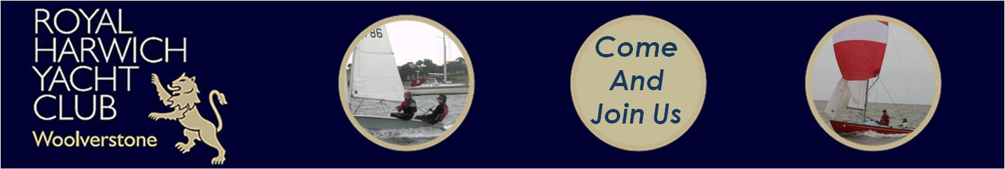

**Sunday**

5th November Council Meeting 09:30 to 12:00

Coach to Felixstowe. Lunch available at Sea Front Restaurants 12:00

Visit Landguard Fort 14:00

Pre-dinner drinks at the Oyster Reach 19:00

Dinner in the Oyster Reach (not included in weekend price) 20:00

**Monday** Farewells 09:00

6th November Commence homeward journeys

Please make your own arrangements to travel to the UK. Advise us of expected arrival at Stansted Airport or London Liverpool Station.

**Nearest Hotel**

Make your own arrangements for Hotel accommodation. Maximising use of the Oyster Reach Premier Inn makes the UK travel arrangement’s achievable. Friday, Saturday and Sunday, on line booking rate £166, 2 person room. Premier Inn, Ipswich South (288), Bourne Hill, Ipswich IP2 8ND. 5 miles up river to the west, on outskirts of Ipswich Junction 56 on A14 east bound.

0871 527 8552 (0044 871 527 8552) Visit [www.premierinn.com](http://www.premierinn.com)

Bus service No 202 heading to Shotley runs between Rail Station and Oyster Reach. Departs 17:14 or 18:39. Five minute journey. Saturday service from Ipswich 14:10, 15:15, 16:10, 17:10. Service 98 and 202 available

**Spirit Yachts** Famed for timeless beauty combined with racing performance and structural integrity, Spirits can be seen competing in classic regattas and cruising in bays all around the world. Whether it’s day sailing, long distance blue water cruising, or performance racing, Spirit’s range of [sail](http://www.spirityachts.com/sailing-yachts/) and [power yachts](http://www.spirityachts.com/power-yachts/) offers ultimate flexibility. The possibility of a custom project provides opportunity for innovation and creativity.

Unlike many yacht builders, Spirit carries out both the design and build process in-house at its waterside headquarters in Suffolk.  With designers and builders in one location, communicating and working side by side, Spirit is able to offer customers a seamless journey from the design stage to the launch of the finished yacht.

**Ipswich Transport Museum** is a [museum](https://en.wikipedia.org/wiki/Museum) devoted to history of transport and engineering objects made or used in its local area. The museum collection was commenced by the Ipswich Transport Preservation Group in 1965. In 1988 it obtained use of its present premises, the old [Priory Heath trolleybus depot](https://en.wikipedia.org/wiki/Trolleybuses_in_Ipswich) in Cobham Road, and has been opened to the public since 1995.

Its collection of more than 100 large objects includes [trams](https://en.wikipedia.org/wiki/Tram), trolley- and motor-[buses](https://en.wikipedia.org/wiki/Bus) from [Ipswich Corporation Transport](https://en.wikipedia.org/wiki/Ipswich_Corporation), the [Eastern Counties Omnibus Company](https://en.wikipedia.org/wiki/First_Norfolk_%26_Suffolk) and other local operators; [commercial vehicles](https://en.wikipedia.org/wiki/Commercial_vehicle); [fire apparatus](https://en.wikipedia.org/wiki/Fire_apparatus); [mobile cranes](https://en.wikipedia.org/wiki/Crane_%28machine%29); [bicycles](https://en.wikipedia.org/wiki/Bicycle); [biers](https://en.wikipedia.org/wiki/Bier); [horse-drawn vehicles](https://en.wikipedia.org/wiki/Horse-drawn_vehicle); [prams](https://en.wikipedia.org/wiki/Baby_transport); and [wheelchairs](https://en.wikipedia.org/wiki/Wheelchair). There is a good representation of the Ipswich manufacturers [Ransomes, Sims & Jefferies](https://en.wikipedia.org/wiki/Ransomes,_Sims_%26_Jefferies) and [Ransomes & Rapier](https://en.wikipedia.org/wiki/Ransomes_%26_Rapier) and of [electric vehicles](https://en.wikipedia.org/wiki/Electric_vehicle).

Local [rail](https://en.wikipedia.org/wiki/Rail_transport) and waterway transport and [aviation](https://en.wikipedia.org/wiki/Aviation) are represented mainly by photographic collections and smaller exhibits. The Museum also houses an archive and library together with costume and ticket collections

**Landguard Fort** Originally known as Langer Fort, the first fortifications from 1540 were a few earthworks and [blockhouse](https://en.wikipedia.org/wiki/Blockhouse), but it was [James I of England](https://en.wikipedia.org/wiki/James_I_of_England) who ordered the construction of a square fort with bulwarks at each corner. In 1667 the [Dutch](https://en.wikipedia.org/wiki/Netherlands) landed a force of 2000 men on Felixstowe beach in front of (what is now called) Under Cliff road east and advanced on to the fort, but [were repulsed by](https://en.wikipedia.org/wiki/Battle_of_Landguard_Fort) [Nathaniel Darrel](https://en.wikipedia.org/w/index.php?title=Nathaniel_Darrel&action=edit&redlink=1) and his garrison of 400 musketeers of the Duke of York & Albany's Maritime Regiment (the first English Marines) and 100 artillerymen with 54 cannon. The last recorded armed invasion of the UK, 350 years ago.

The fort was considered part of [Essex](https://en.wikipedia.org/wiki/Essex) in the 18th and 19th centuries; births and deaths within the garrison were recorded as 'Landguard Fort, Essex'. A new Fort [battery](https://en.wikipedia.org/wiki/Artillery_battery) was built in 1717, and a complete new fort on an adjoining site was started in 1745 to a pentagonal [bastioned](https://en.wikipedia.org/wiki/Bastion) trace. New batteries were built in the 1750s and 1780, but the biggest change was in the 1870s where the interior [barracks](https://en.wikipedia.org/wiki/Barracks) were rebuilt to a keep-like design, the river frontage was rebuilt with a new casemated battery covered by a very unusual [caponier](https://en.wikipedia.org/wiki/Caponier) with a quarter sphere bomb proof nose. Several open bastions were enclosed, and a mock [ravelin](https://en.wikipedia.org/wiki/Ravelin) block constructed to house a submarine mining contingent.

During the [Second World War](https://en.wikipedia.org/wiki/World_War_II), it was used as one of the balloon launch sites of [Operation Outward](https://en.wikipedia.org/wiki/Operation_Outward). This was a project to attack [Germany](https://en.wikipedia.org/wiki/Germany) by means of free-flying hydrogen balloons that carried incendiary devices or trailing steel wires (intended to damage power lines.) Between 1942 and 1944, many thousands of balloons were launched.

The 10inch gun pit in Left Battery was converted into an [Anti-aircraft](https://en.wikipedia.org/wiki/Anti-aircraft) Operations Room for Harwich in 1939. The fort has been structurally consolidated and is open every day from April to the end of October. It is now in the guardianship of [English Heritage](https://en.wikipedia.org/wiki/English_Heritage).

**Guy Fawkes and 5th November 2017** For 400 years, bonfires have burned on November 5th to mark the failed Gunpowder Plot.

The tradition of Guy Fawkes-related bonfires actually began the very same year as the failed coup. The Plot was foiled in the night between the 4th and 5th of November 1605. Already on the 5th, agitated Londoners who knew little more than that their King had been saved, joyfully lit bonfires in thanksgiving. As years progressed, however, the ritual became more elaborate.

Soon, people began placing effigies onto bonfires, and fireworks were added to the celebrations. Effigies of Guy Fawkes, and sometimes those of the Pope, graced the pyres. Still today, some communities throw dummies of both Guy Fawkes and the Pope on the bonfire (and even those of a contemporary politician or two), although the gesture is seen by most as a quirky tradition, rather than an expression of hostility towards the Pope.

Preparations for Bonfire Night celebrations include making a dummy of Guy Fawkes, which is called "the Guy". Some children even keep up an old tradition of walking in the streets, carrying "the Guy" they have just made, and beg passersby for "a penny for the Guy." The kids use the money to buy fireworks for the evening festivities.

On the night, itself, Guy is placed on the bonfire, which is then set alight; and fireworks displays fill the sky.

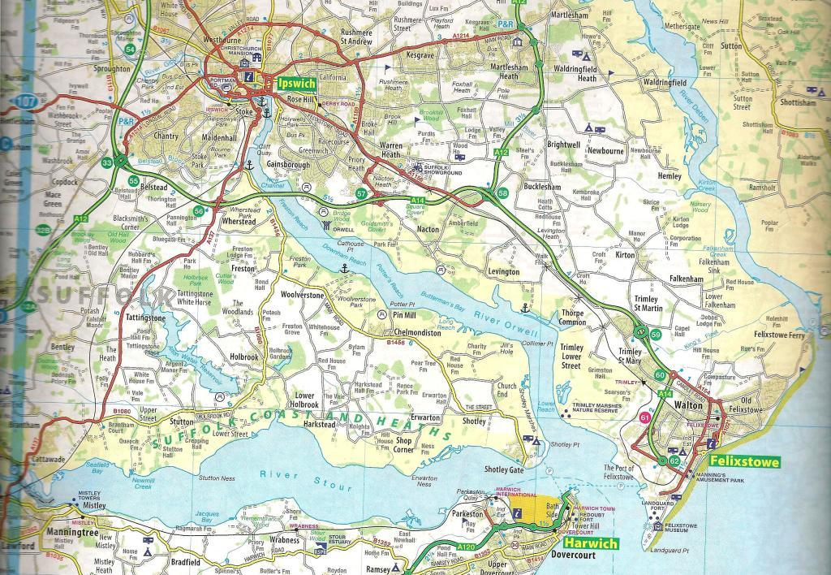 Landguard & Felixstowe 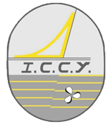

Premier Inn, Bourne Bridge Royal Harwich YC